Church Service content

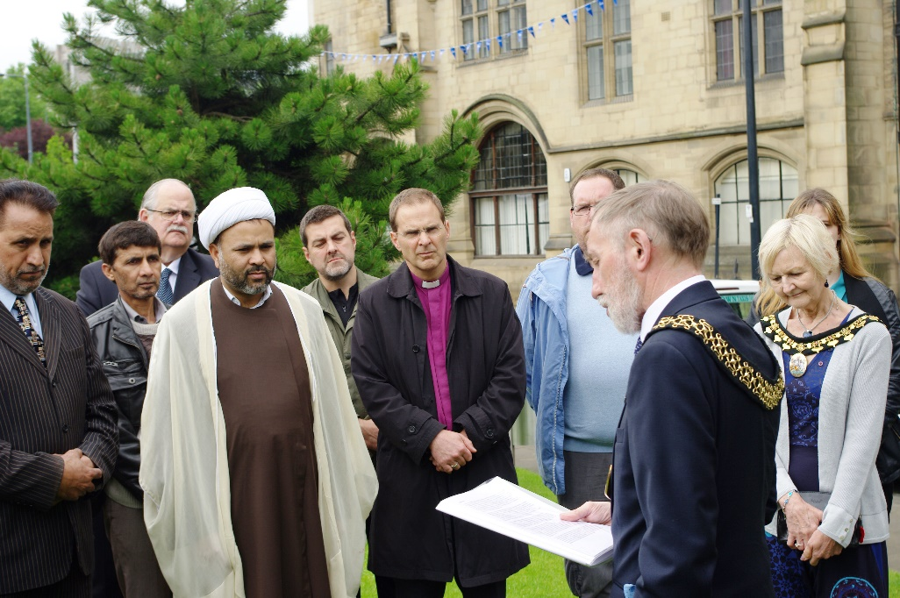

History
Humanity has lived through the darkest of times, but few events have stained our collective soul more than the Srebrenica genocide. During the Balkans conflict of 1992-1995, Serb nationalist forces waged a co-ordinated campaign of ‘ethnic cleansing’ intended to create a ‘Greater Serbian’ territory.
In July 1995, Bosnian Serb forces, led by General Ratko Mladić overran and captured the town of Srebrenica in Eastern Bosnia which had been declared a UN Safe Area in 1993. In the days following Srebrenica’s fall, more than 8,000 Bosnian Muslim men and boys were systematically massacred and buried in mass graves. Thousands of women, children and elderly people were forcibly deported. Throughout Bosnia, between 20,000 – 50,000 women and girls suffered rape and sexual violence; a weapon of war used to systematically ‘ethnically cleanse’ communities and terrorise them into fleeing.

Described by the United Nations as ‘the worst crime on European soil since the Second World War’, the massacres at Srebrenica were classed as genocide by both the International Court of Justice and the International Criminal Tribunal for the former Yugoslavia. Yet denial of this atrocity is widespread.
Many in Bosnia-Herzegovina are still struggling for justice, not least the women who were left to pick up the pieces after their families and whole communities were wiped from during the genocide. The Mothers Association of Srebrenica were among the first to collect and document the names of those who were killed and they provided this information to The Hague. They campaign tirelessly so that the memory of their loved ones is preserved, and to ensure that such atrocities never happen again.
On the 11th July, the official date of remembrance each year, we honour the victims and survivors of the genocide, and pledge ourselves to creating a better, stronger and more cohesive society in the United Kingdom.
The lessons learned from Srebrenica are that hatred and intolerance can flourish if left unchallenged. Even in Bosnia-Herzegovina, where people of different faiths had lived peacefully together for many years, an integrated society disintegrated. We must all understand the consequences of leaving hatred and intolerance unchallenged. By doing this, we give ourselves hope of illuminating the darkness and creating a better, safer and stronger society for all.
Story of a Survivor: Nirha Efendić

Nirha Efendić was only 13 years old when the war in Bosnia began. Now a mother of three, she reflects on what it was like to be a child of war.
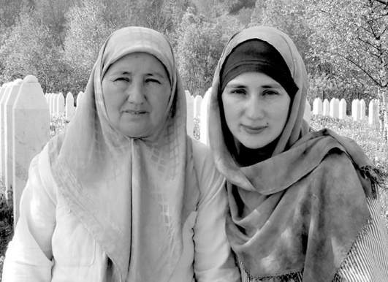
“I was the youngest child in my family. I had an older brother who was around 16 when the war broke out. You could say we were more aware of the situation because my father was a politician. He was a principled man, who wanted to save his people. And for that reason, he insisted that we stay in Srebrenica when the war began.
At the time, Srebrenica was a Muslim-majority town, with 75% of the population being Bosnian Muslim. My father decided that we would resist the oppression. He spoke to many people in the town about this, and they all agreed. This was their home, and they would not be chased off by anyone. I remember being mesmerised as a child by the way my father spoke; he had such courage and conviction in what he said.
By the time of the genocide, I was 15. As the Serbian military descended upon Srebrenica, we ran for cover. The UN base in Potočari was completely full. So we hid in a nearby factory. My father and brother fled, but they couldn’t catch up to the men who had already left. I was told that they were captured by the Serbian military in the hills surrounding Srebrenica.
Meanwhile, my mother and I were in the empty factory with thousands of other women and children for three days. We had no food, and no water. By the fourth day, the Serbian military escorted us onto busses and trucks headed towards the free territory. The journey, which takes a maximum of one hour, took four gruelling hours to complete because of the sheer magnitude of women and children that needed to be transported.

Suffering from exhaustion and a high fever, I was completely unaware of what was happening around me. When we arrived in the free territory, I distinctly recall hearing screams coming from the river. But I never turned back to see what was happening.
I just wanted to keep walking forward; away from the chaos, and away from the stench of death that hung heavily in the air. I can still hear those screams today.

A month later, we heard about my father. He had been kept in a hangar in Kravica with several other men, and later executed. His remains were finally identified in 2002 in a mass grave in Srebrenica, and we buried him in 2004. Four years ago, we heard about my brother. They found just 25% of his mortal remains in secondary mass graves. He was killed in Zvornik, just 19 days before his 20th birthday. On 11th July this year, we will bury the pieces of him they found.
I had definitely grown up by the time the conflict was over. My family was literally cut in half; my father and brother snatched from us in the most horrific way. And yet I understood that life had to go on. My mother enrolled me at a school in Zagreb, Croatia, and she went to Germany as a refugee. She insisted that I gain a full education to learn about the history of the world, and recognise that I had to be part of the educated majority who could actively do something to stop such an atrocity from ever happening again. Whilst I understand why she sent me to Zagreb, parting from her after what we went through together, especially at that age, was very difficult for me.
After I finished secondary school, I returned to Bosnia with my mother. We rented a flat in Sarajevo until I graduated, and then my mother moved back to Srebrenica. I always knew that she would go back. She believes in justice, and she wanted to fight for what was and is rightfully hers — her home. So I was adamant to support her.
But I chose to make a life for myself in Sarajevo. I married, had children, and attempted to continue with my life. But the war, and in particular, the genocide, continue to haunt me. That sort of experience scars you in a way that cannot be communicated in words. I go back to Srebrenica at every opportunity I get. Not only for my mother, but also for myself — as a method of finding some stillness now in memories that are seared with the chaos of bloodshed and horror.
I pray that my three children grow up to be kind, tolerant people.

I want to teach them to always to be aware of everything around them, and to be smart about the decisions they make. I want to teach them about my past, so that they can be aware of their history. But for now, I just want them to enjoy a happy, carefree childhood, where they can feel safe and protected in their own home.

Prayer

O God of truth and justice,
we remember today the consequences of hatred
in lives brutally extinguished
in hearts torn apart
in memories scarred with pain.
As we remember and honour the victims of hatred,
lead us to sorrow over the sins of humanity.

Draw close, we pray,
to mothers and sisters,
wives and grandmothers
and all relatives and loved ones left behind,
and heal the pain in their souls.

And teach us, O Lord,
to learn how to live for a world
where differences are respected and valued,
and where fear and mistrust
can never overwhelm us
nor vengeance be stirred in our hearts.

Give peace we pray, to the people of Srebrenica;
that their lives may be restored
through your grace. Amen.

- Prepared by Reverend Julian Francis, St George’s Edgbaston

Candle Lighting
We come together today to remember the victims of the Srebrenica genocide.

We light these candles in remembrance of the lives lost and destroyed by hatred:

- We remember the 8,372 mostly Muslim men and boys who were murdered in the space of a week in Srebrenica in July 1995.

- We remember the Bosniak women and girls that were sexually violated during the fall of Srebrenica, those who took their own lives, and those who live on with physical and emotional scars.

- We remember the survivors of the Death March, and the men who survived the mass executions, and honour their courage in telling their stories.

- We remember the Mothers of Srebrenica, who grieve every day for their missing and killed relatives and who fight tirelessly for truth and justice.

- We remember the elderly, the sick and the children murdered during the fall of Srebrenica.

- We remember the Bosniak men murdered in concentration camps throughout the Bosnian conflict, and those who survived torture, starvation and sexual violence within the camps.

- We remember the 20,000 – 50,000 women and girls subjected to sexual violence throughout the war, including those subjected to sexual slavery, torture and forced domestic labour in rape camps.

- We remember the women and girls who were forcibly impregnated by Bosnian Serb soldiers, and the children born from those rapes.

- We remember the civilians killed during the conflict, particularly the 3,500 children and those killed during the siege of Sarajevo.

- We remember those who defended their neighbours in a war not of their making.

- We remember the 2 million Bosnians who were forcibly displaced from their homes and communities through ethnic cleansing, and especially those who remain internally displaced today.

Living the Lessons Pledge
As an act of commemoration, we suggest 11 candles to be lit for each pledge made to honour the international day of Srebrenica commemoration which takes place on 11 July each year.

- We pledge that when we hear the language of “us and them”, we will reach out and find common ground with our neighbour.

- We pledge that, when we hear stereotyping and scapegoating, we will find and share alternative positive stories.

- We pledge that, when we see discrimination in our schools or workplaces, we will challenge this and promote equal opportunities for all.

- We pledge that, when we hear dehumanising language, we will remind the speaker of our common humanity.

- We pledge that, when we see members of our community becoming disenfranchised, we will make an effort to engage and include them.

- We pledge that, when we hear divisive propaganda, we will challenge this effectively.

- We pledge that we will protect those who speak out against human rights abuses.

- We pledge that, where we see persecution, we will do everything in our power to protect those who are suffering.

- We pledge that, where we believe that extermination is taking place, we will call on our governments and the international community to take immediate action.

- We pledge that we will always challenge denial by believing the victims and sharing their stories.

- We pledge that we will always choose the side of those who are suffering over the side of the oppressor.

The Srebrenica Prayer

We pray to almighty God,
May grievance become hope
May revenge become justice
May mothers' tears become prayers
That Srebrenica Never happens again
To no one and nowhere

Remembering Srebrenica is the UK charity which aims to teach current and future generations about the consequences of hatred and intolerance in all communities through learning the lessons of Srebrenica. We are calling on all communities to Remember the victims and survivors of the Srebrenica genocide; Learn the lessons from Srebrenica, particularly that we must always be vigilant against hatred and intolerance in our communities and Pledge to take action now to build better and safer communities for all.
srebrenica.org.uk

